**Elements of a Wireless Communication System**

The most basic possible wireless system consists of a transmitter, a receiver, and a channel, usually a radio link.

radio cannot be used directly with low frequencies such as those in a human voice, it is necessary to superimpose the information content onto a higher frequency **carrier** signal at the transmitter, using a process called **modulation**.

The use of modulation also allows more than one information signal to use the radio channel by simply using a different carrier frequency for each.

The inverse process, **demodulation**, is performed at the receiver in order to recover the original information.

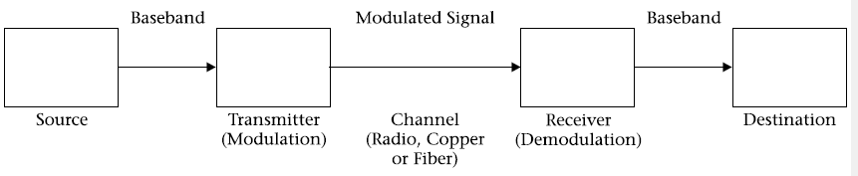

**Elements of a communication system**

The information signal is also sometimes called the intelligence, the modulating signal, or the **baseband signal**. An ideal communication system would reproduce the information signal exactly at the receiver, except for **the inevitable time delay** as it travels between transmitter and receiver, and except, possibly, for a change in amplitude. Any other changes constitute **distortion.**

communication can take place in both directions (transmitter to receiver and vice versa) at once. This is called full-duplex communication. An ordinary telephone call is an example of full-duplex communication. It is quite possible (though perhaps not desirable) for both parties to talk at once, with each hearing the other. Figure 1.2 shows full-duplex communication.

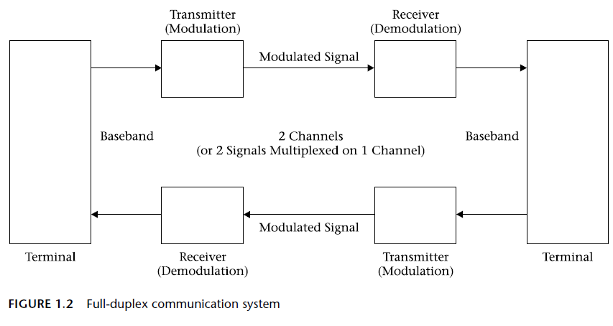

**half-duplex** two-way communication systems do not require simultaneous communication in both directions. An example is a conversation over citizens’ band (CB) radio.

The operator pushes a button to talk and releases it to listen. It is not possible to talk and listen at the same time, as the receiver is disabled while the transmitter is activated.

Half-duplex systems **save bandwidth** by allowing the same channel to be used for communication in both directions. They can sometimes **save money** as well by allowing some circuit components in the transceiver to be used for both transmitting and receiving.

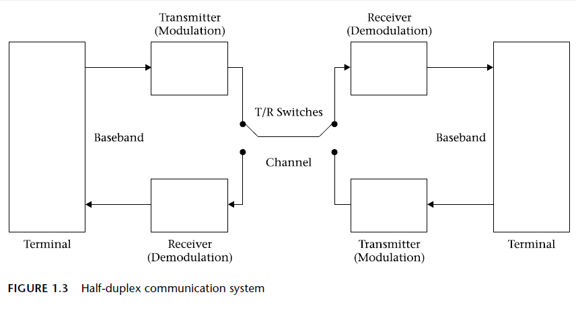

When there are more than two simultaneous users, or when the two users are too far from each other for direct communication, some kind of network is required. Probably the most common basic structure in wireless communication is the **classic star network**, shown in Figure 1.4. The central hub in a radio network is likely to be a **repeater**, which consists of a transmitter and receiver, with their associated antennas, located in a good position from which to relay transmissions from and to mobile radio equipment. The repeater may also be connected to wired telephone or data networks. The cellular and PCS telephone systems uses repeater stations.

**Signal and noise**

A signal is used to carry useful information; and in every case there is **noise**, which enters the system from a variety of sources and degrades the signal, reducing the quality of the communication.

Keeping the ratio between signal and noise sufficiently high is the basis for a great deal of the work that goes into the design of a communication system.

This **signal-to-noise ratio**, abbreviated *S/N* and almost always expressed in decibels, is an important specification of virtually all communication systems.

Given the necessity for modulating a higher-frequency signal with a lower-frequency baseband signal, it is useful to look at the equation for a sine-wave carrier and consider what aspects of the signal can be varied. A general equation for a sine wave is:



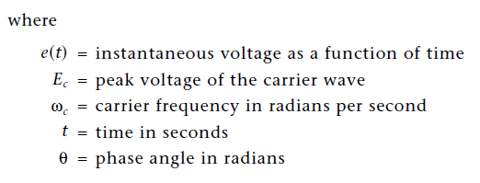

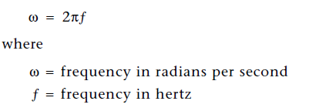

**Noise**

All electronic systems are affected by noise, which has many sources, the most important noise component is **thermal noise**, which is created by the **random motion of molecules** that occurs in all materials at any temperature above absolute zero (0 K or -273° C).

Thermal noise power is proportional to the bandwidth over which a system operates. The equation is very simple:



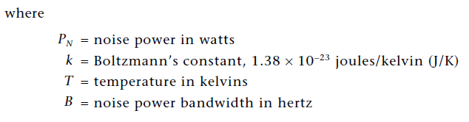

***Bandwidth***refers to the range of frequencies over which the noise is observed. If we had a system with infinite bandwidth, theoretically the noise power would be infinite. Of course, real systems never have infinite bandwidth.

Converting between degrees Celsius and kelvins is easy:

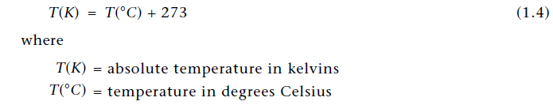

**Signal-to-Noise Ratio**

Maintaining an adequate ratio of signal power to noise power is essential for any communication system

There are two basic ways to improve *S/N*: increase the signal power or reduce the noise power.

Increasing signal power beyond a certain point can cause problems, particularly where portable, battery powered devices are concerned.

Reducing noise power requires limiting bandwidth and, if possible, reducing the noise temperature of a system.

The system bandwidth must be large enough to accommodate the signal bandwidth, but should be no larger than that.

**Noise Figure and Noise Temperature**

Noise figure describes the way in which a device adds noise to a signal and thereby degrades the signal-to-noise ratio. It is defined as follows:

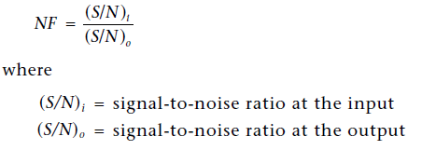

When a device has multiple stages, each stage contributes noise, but the first stage is the most important because noise inserted there is amplified by all other stages. The equation that expresses this is:

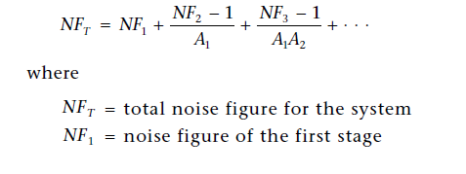 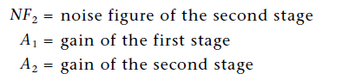

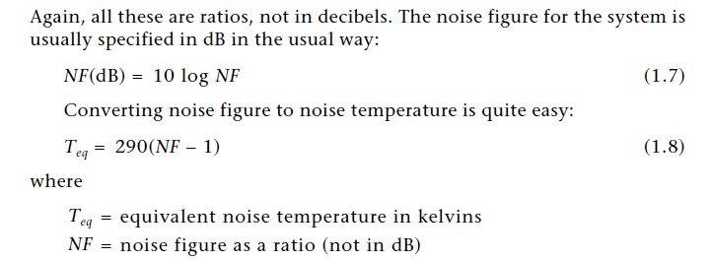

The noise temperature due to the equipment must be added to the noise temperature contributed by the antenna and its transmission line to find the total system noise temperature

**Problem:**

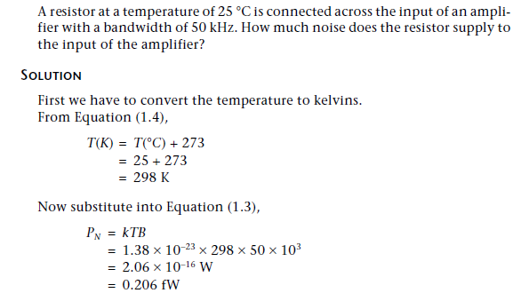

**Signal-to-Noise Ratio**

It is the ratio of signal power to noise power

There are two basic ways to improve S/N: increase the Signal power or reduce the noise power.

Increasing signal power beyond a certain point can cause problems, particularly where portable, battery powered devices are concerned.

Reducing noise power requires limiting bandwidth and, if possible, reducing the noise temperature of a system

**Noise Figure and Noise Temperature**

Noise figure describes the way in which a device adds noise to a signal and thereby degrades the signal-to-noise ratio. It is defined as follows:

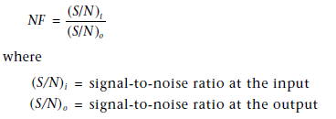

When a device has multiple stages, each stage contributes noise, but the first stage is the most important because noise inserted there is amplified by all other stages. The equation that expresses this is:

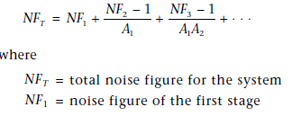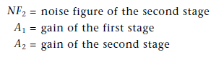

The noise figure for the system is usually specified in dB in the usual way:

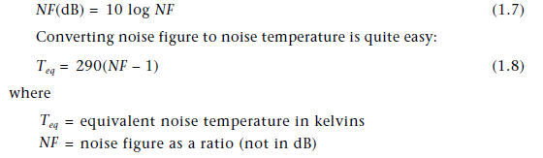

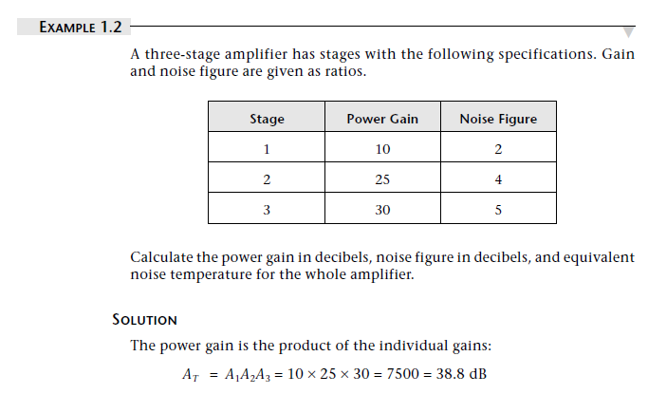

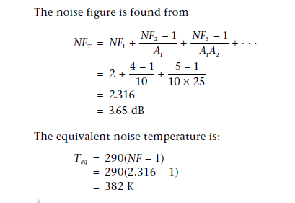

**The Radio-Frequency Spectrum**

Radio waves are a form of electromagnetic radiation, as are infrared, visible light, ultraviolet light, and gamma rays. The major difference is in the frequency of the waves. The portion of the frequency spectrum that is useful for radio communication at present extends from roughly 100 kHz to about 50 GHz.

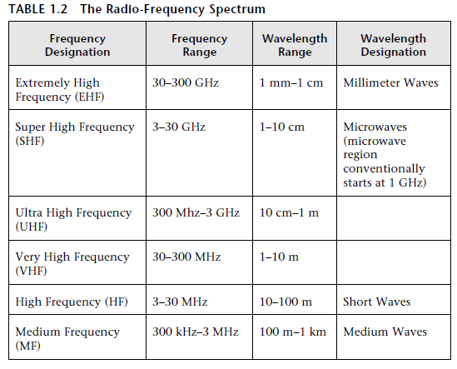

The general equation that relates frequency to wavelength for any wave is

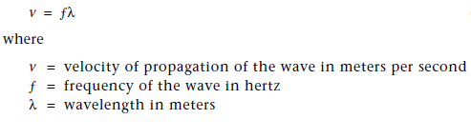

For radio waves in free space (and air is generally a reasonable approximation

to free space) the velocity is the same as that of light: 300 × 106 m/s. The usual symbol for this quantity is c. Equation (1.11) then becomes:



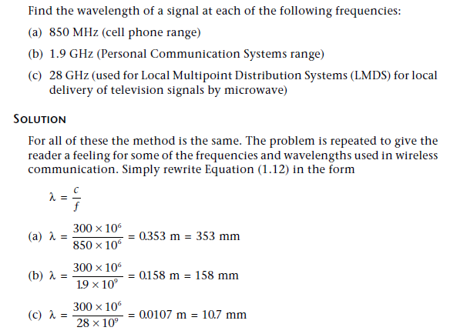

**Hartley’s Law** which relates bandwidth, time, and information content

